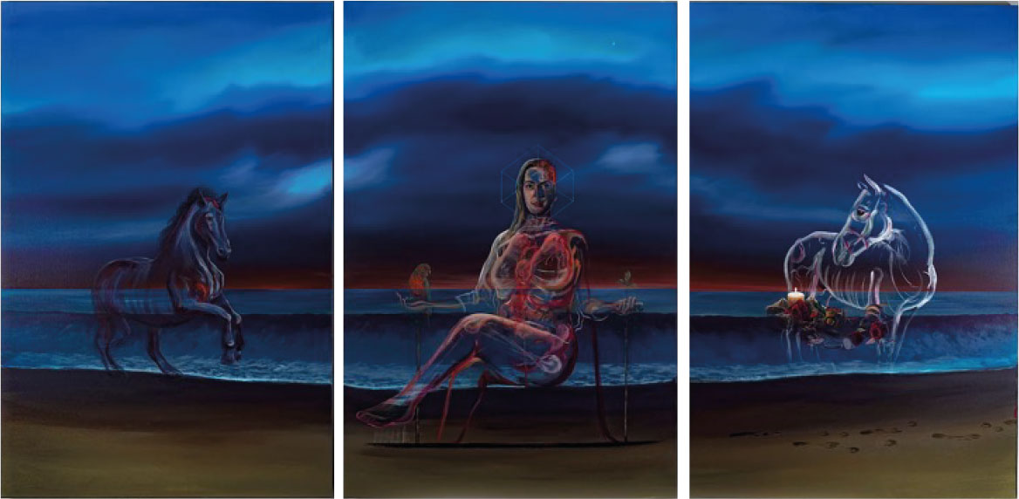

Triptych Portrait of Vicky Phelan by Vincent Devine (2018)

Emissary of Light

Three panels hang side by side as if they came from paradise.
Eyes glowing like luminous jewels of light through thickening promises.
Riding surf and waves with messages of hope breaking from sea to shore.
Your milky skin glowing through a galaxy of grief no more.

I dread the hangover of your parting.
For now, we swim alone.
Disoriented beneath a negative smear, a desultory cloud,
Thickening each life span like a shroud.

If I could swim outside my window,
Mobilize new pathways through stagnant healthcare algae,
Make the invisible visible through the perilous path of illness,
I would dredge through swamps of failure that failed to silence your success.

I would challenge the oppressive legacy of state neglect,
Lay Pembro on a plate before it got too late,
Keep your campaign moving ruthlessly along,
Your transcendence a model to model all others on.

You want no dignitaries in a gloom-filled room whispering waves of promises.
Between church bells and dog barks, there is no place for politics.
Not while women die, I hear you cry – “don’t lie to the souls set free,
There are no more Four Courts for me.”

This poem is dedicated to Vicky Phelan, a courageous advocate for women's health and a relentless campaigner for justice. Her legacy continues to inspire and bring about change in the fight against cervical cancer and healthcare negligence. Vicky's strength and determination remain a beacon of hope for many.

